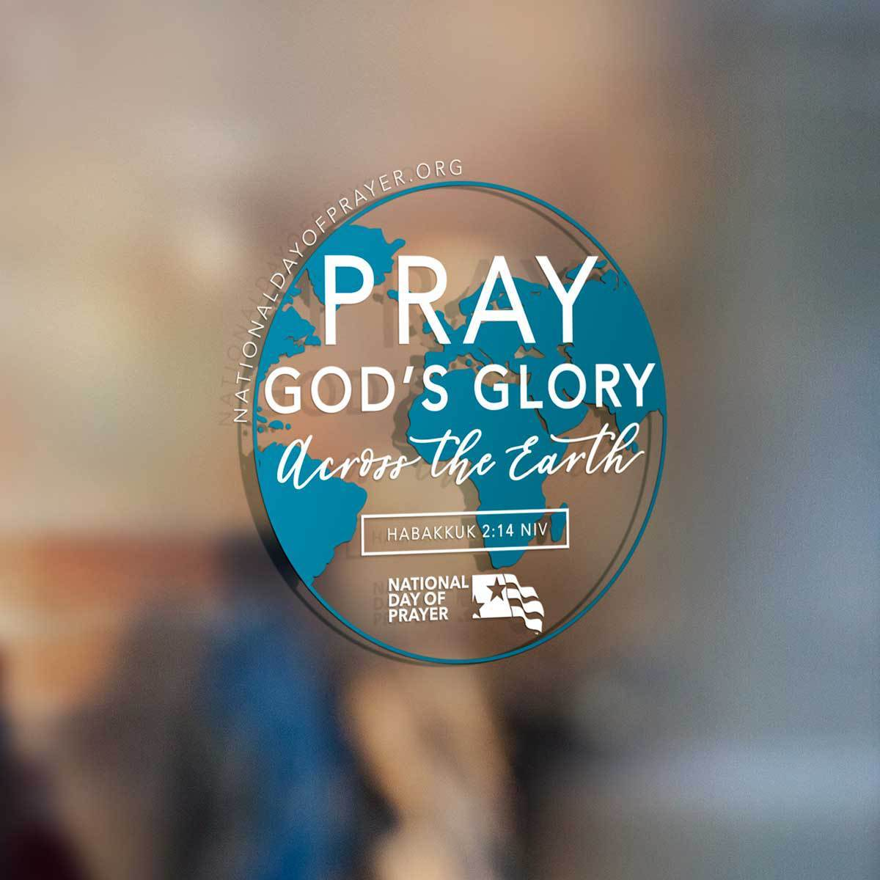
Noordeloos Christian Reformed Church
In May 1988 the President of the United States signed into law a bill establishing the first Thursday of May as a National Day of Prayer. This year the National Day of Prayer falls on Thursday, May 7.

The synod of the CRC has urged churches in the United States “to observe faithfully any national day of prayer which the United States President publicizes to the nation” (Acts of Synod 1969).

In 1958, synod urged that, “Our churches must be open to our congregations and our fellow [citizens] on such occasions, when God in his providence leads those in civil authority to call our citizenry to pray. We must pray for and with our country” (Acts of Synod 1958). This year our church buildings cannot be open, but in the midst of the suffering and fear caused by the COVID-19 global pandemic, we can join our hearts in prayer for our nation and our world. (from the CRCNA web-site)

National Day of Prayer Service
May 7, 2020—7:00 PM
Prelude—All Who Are Thirsty

Entering God’s Presence
Call to Prayer: Matthew 7:7-11
The Lord’s Greeting
Opening Hymn—Sweet Hour of Prayer

Preparation for Prayer from God’s Word
Scripture: Habakkuk 2:14
Meditation: Praying for God’s Glory Across the Earth

Engaging in a Season of Prayer
Song—Holy Spirit (chorus x2)
Prayer for Global Concerns—Hannah Johnston
Prayer for our Nation—Steve Gerritsma
Song—Build Your Kingdom Here
Prayer for Livelihood/Daily Bread—Keith Johnston
Prayer for our Schools/Education—Megan Mokma
Song—Abide with Me (PH 442 vs 1,3)
Prayer for Noordeloos Church—Pastor Ron DeYoung
Prayer for our Families—Sarah Mokma

Leaving in Gratitude and Trust
Song of Assurance—Always
The Lord’s Blessing
Postlude—Trust You

Worship Participants
Worship Leader: Rev. Ron DeYoung
Pianist: Kathryn Zeinstra
Praise Team: Steve Gerritsma, Megan Mokma, Sarah Mokma

