Noordeloos Christian Reformed Church
April 3, 2026—7:00 PM
Good Friday Tenebrae Service

Prelude
Welcome
*Call to Worship—Isaiah 53:3-6
*God’s Greeting
*Opening Song—How Deep the Father’s Love for Us
Scripture: Hebrews 12:1-3 (page 1170)
Message: Behold Our Suffering Servant
Song—HWC 210 vs. 1, 3—Jesus Paid It All

Jesus and the Mob—Matthew 26:47-56
Song—HWC 185 vs. 1, 3, 4—When I Survey the Wondrous Cross

Jesus and the Sanhedrin—Luke 22:66-71
Song—HWC 177 vs. 1-3—What Wondrous Love Is This

Jesus and Pilate—Matthew 27:1-3, 11-26
*Song—HWC 178 vs. 1-2—O Sacred Head, Now Wounded

Jesus and the Cross—Mark 15:16-32
Song—HWC 176 vs. 1, 2, 4—Lead Me to Calvary

Jesus and Death—Luke 23:34a, 39-43; John 19:26-27;
Matthew 27:45-46; John 19:28-30; Luke 23:45b-46
Song—HWC 181 vs. 1-3—Were You There?

Jesus and the Tomb—Luke 23:50-56
*Song—The Power of the Cross

Jesus and Darkness—Psalm 88
*Leave in Silence, Leave in Darkness, Wait in Hope, Return with Joy

Worship Participants
Worship Leader: Pastor Brady Mulder
Piano: Kathryn Zeinstra
Readers: Jason Wisselink, Jared Vander Zwaag, Alyssa Gerritsma,
Chris Sloothaak, John Sietsema, Marv & Von Visser, Sarah Mokma
* Please stand if you are able
Good Friday Message—April 3, 2026
Pastor Brady Mulder
Hebrews 12:1-3
Behold Our Suffering Servant

I. Remember the Spectators (vs 1a)

II. Remember Your Training (vs 1b)

III. Remember Our Suffering Servant (vs 2-3)

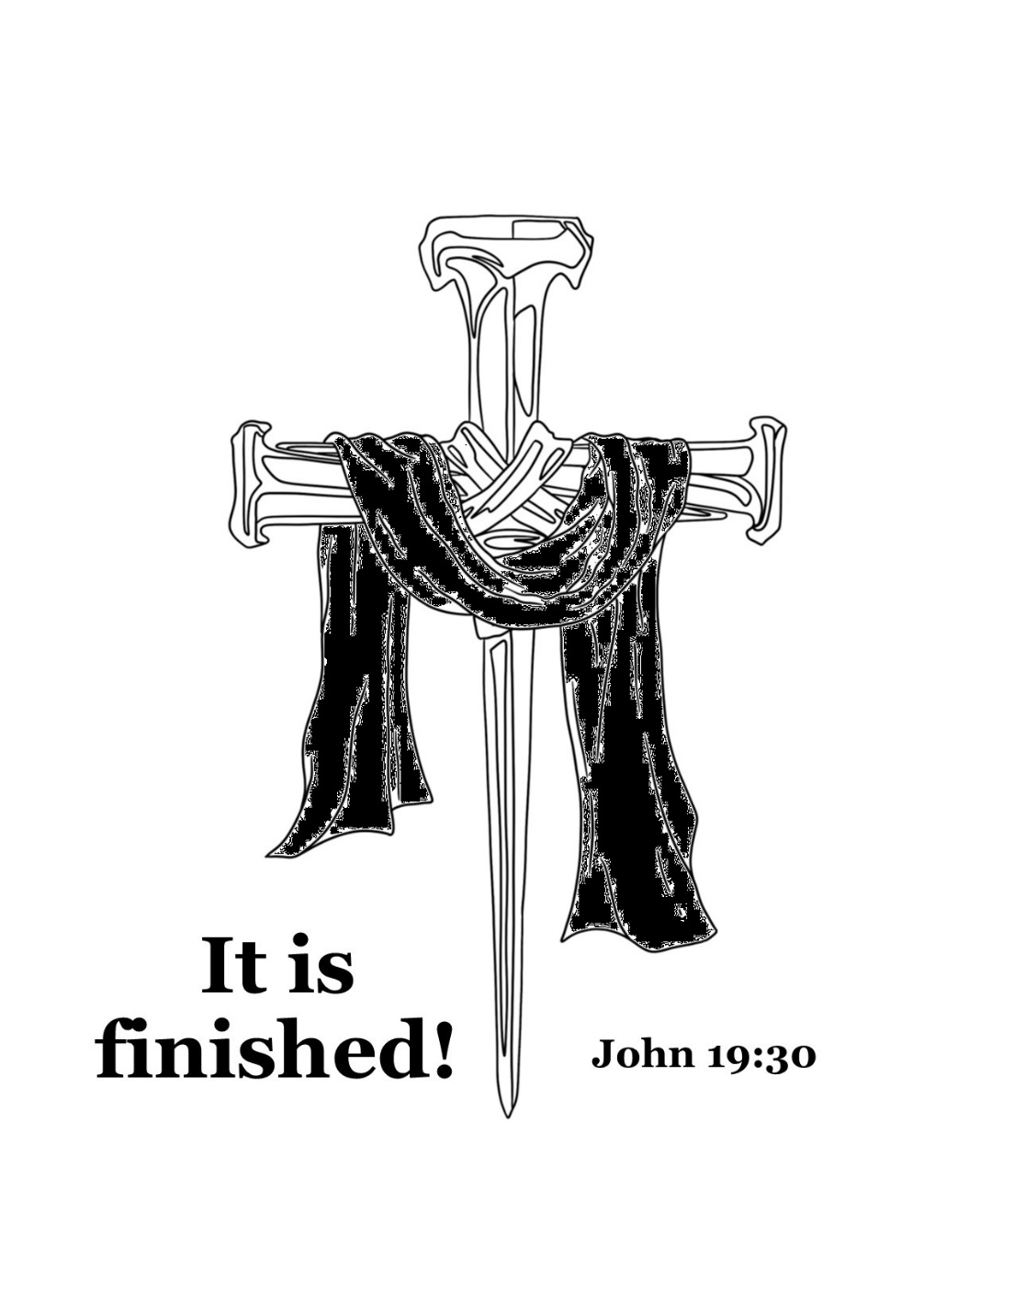
Noordeloos Christian Reformed Church
Good Friday Service

